Annamacharya institute of technology and science,kadapa

To Supply Leftover Food to Poor

By

Yerrakkagari chaithra

chaithra.reddy63037@gmail.com

Project overview:-

This project, "Food Connect: To Supply Leftover Food to Poor," is focused on creating a platform to streamline the redistribution of surplus food to underserved communities, designed to address the dual challenge of food wastage and hunger. The goal is to deliver a comprehensive solution by leveraging the Salesforce platform with tools like custom objects, Lightning apps, and automation workflows. Through this project, we aim to enhance operational efficiency, transparency, and community engagement while supporting the long-term vision of creating a sustainable food-sharing ecosystem.

Key features:-

Custom Objects & Relationships: Tailored objects for Drop-Off Points, Volunteers, and more.

- Automation: Flows and triggers to simplify and automate logistics.

- Reports & Dashboards: Data-driven insights at a glance.

- User-Friendly Interface: Intuitive navigation via tabs and a Lightning App.

Objective:-

To create a sustainable and efficient system for collecting surplus or leftover food from households, restaurants, events, and institutions, and redistributing it to underprivileged and food-insecure individuals and communities, thereby reducing food waste and promoting social equity.

Goals of supply food for poor :-

1. **Reduce Food Waste:**

* Minimize the amount of edible surplus food discarded by households, restaurants, hotels, canteens, and events.

1. **Address Hunger and Malnutrition:**

* Provide timely and nutritious meals to the underprivileged, homeless, and food-insecure populations.

1. **Establish a Collection and Distribution Network:**

Build a reliable logistics system for collecting, storing, and safely transporting leftover food to distribution centers or directly to beneficiaries.

1. **Raise Awareness and Encourage Participation:**

Promote awareness among food donors (individuals and institutions) about food wastage and encourage them to contribute regularly.

Detailed Description of implemented Features:-

Salesforce Developer Account Creation:

* To setup for a salesforce account.
* To login to your salesforce account.
* Account activation.

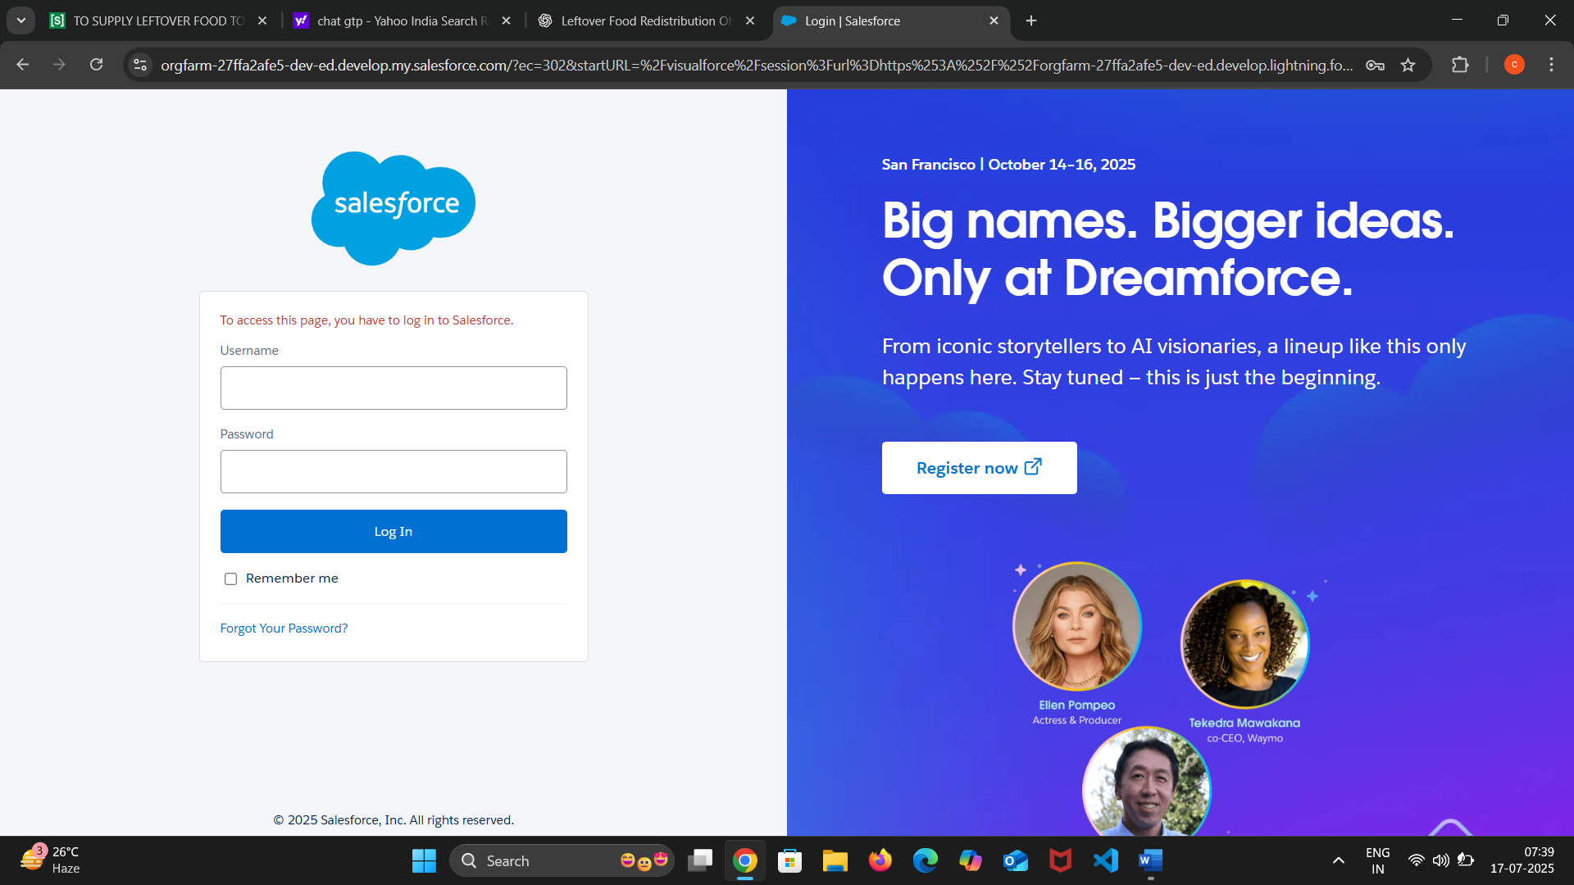

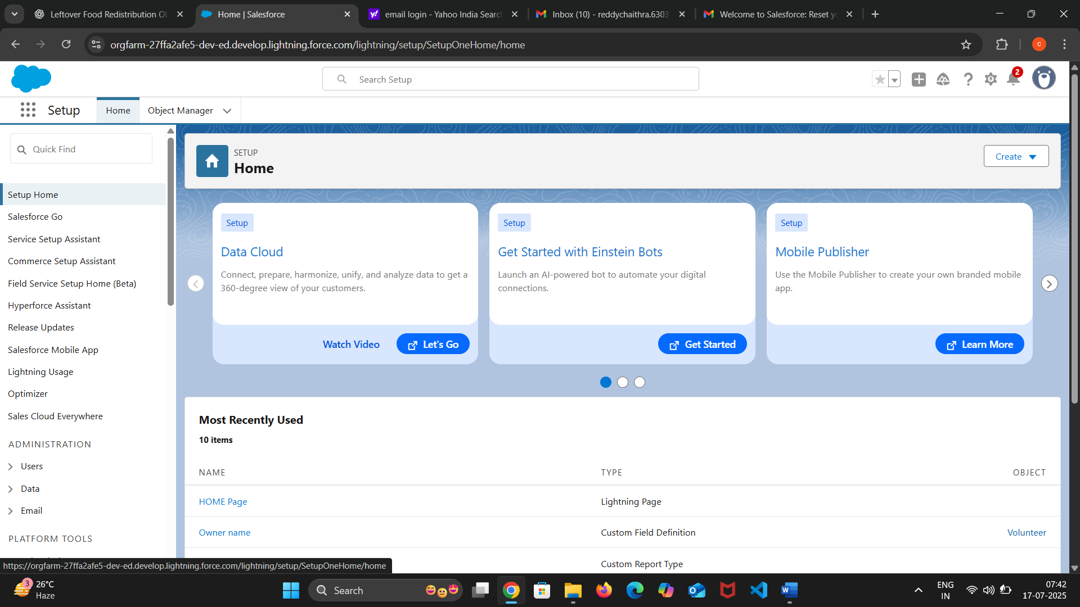

Object Creation:-

Venue:

The venue for the leftover food distribution project will be created by identifying and organizing specific physical locations that serve different roles in the process—collection, storage, and distribution. Collection venues will include restaurants, hotels, hostels, event halls, and canteens, where surplus food is gathered after service hours or events. These venues will be officially registered and equipped with basic infrastructure for hygienic food handling.

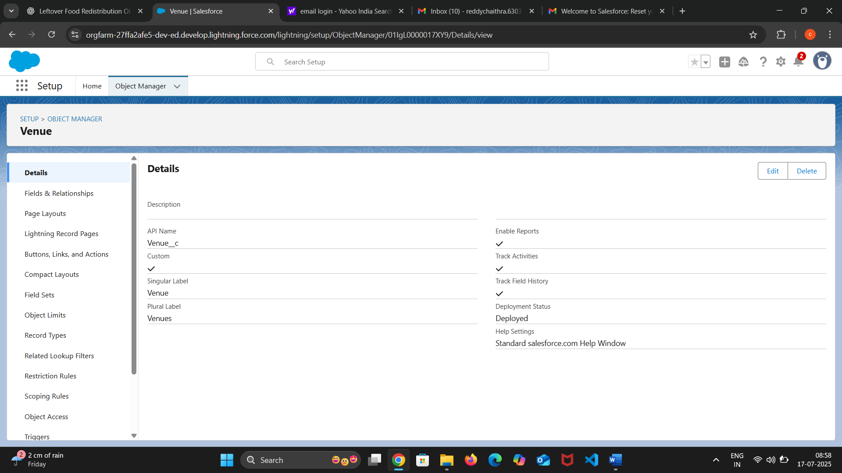

Task:-

The task object creation for the leftover food distribution project involves defining and organizing all essential activities required to successfully implement and manage the initiative. Each task will be clearly outlined with specific responsibilities, timelines, and required resources. Key tasks include identifying food donor sources, coordinating collection schedules, managing food storage and safety checks, organizing volunteer participation, and planning distribution routes.

Volunteer:-

The volunteer object creation for the leftover food distribution project involves identifying, recruiting, and organizing individuals who are willing to contribute their time and effort to support the initiative. Volunteers will be assigned specific roles such as food collection, packaging, quality checking, transportation, and distribution at various venues. Each volunteer's profile will include their availability, area of operation, skills, and preferred tasks to ensure efficient task assignment.

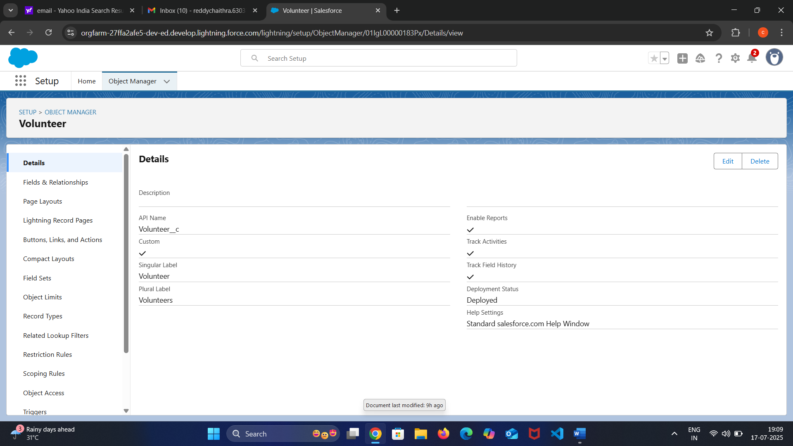

Execution Details:

The execution of the project to supply leftover food to the poor involves a structured process beginning with partnerships established between food providers—such as restaurants, event organizers, hotels, and households—and the redistribution network.

These food donors notify the system through a mobile app or web portal whenever surplus food is available. A real-time tracking and alert system assigns nearby registered volunteers or delivery agents to collect the food, ensuring timely pickup while maintaining food safety standards. Collected food is transported to designated community centers, shelters, or directly to identified poor and hungry populations in urban or rural areas.

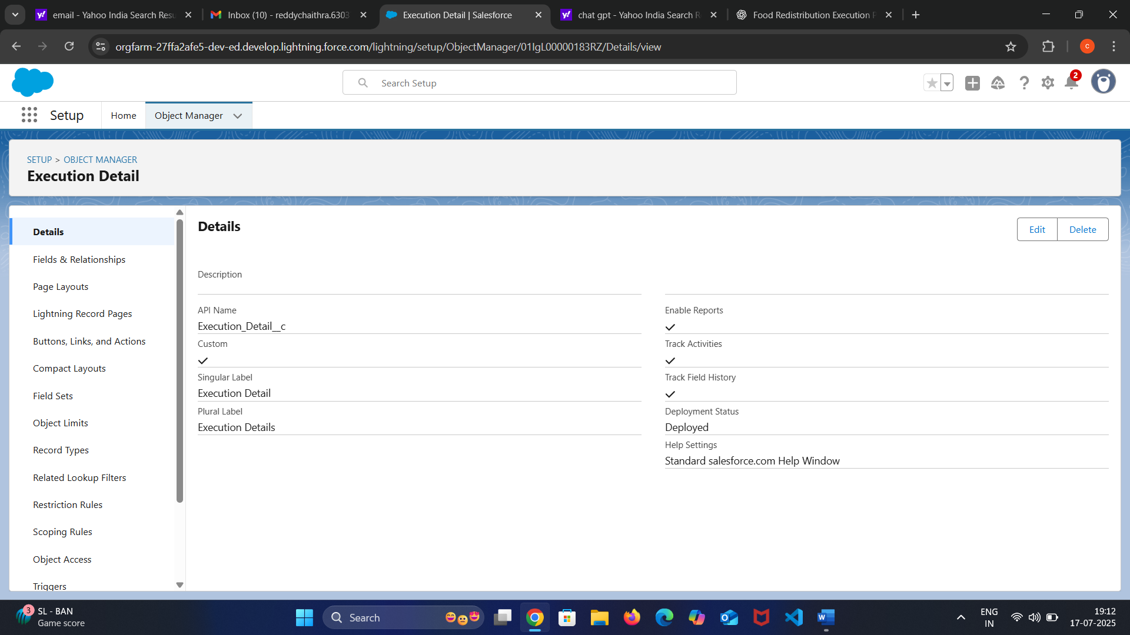

Drop-off Point:-

The drop-off points for distributing leftover food to the poor are strategically selected based on accessibility, population density, and the presence of vulnerable communities. These locations include slum areas, orphanages, old age homes, shelters, community centers, and roadside hubs where daily wage workers and homeless individuals gather. Each drop-off point is coordinated with local volunteers or NGOs to ensure the food is safely distributed and reaches the intended recipients without delay.

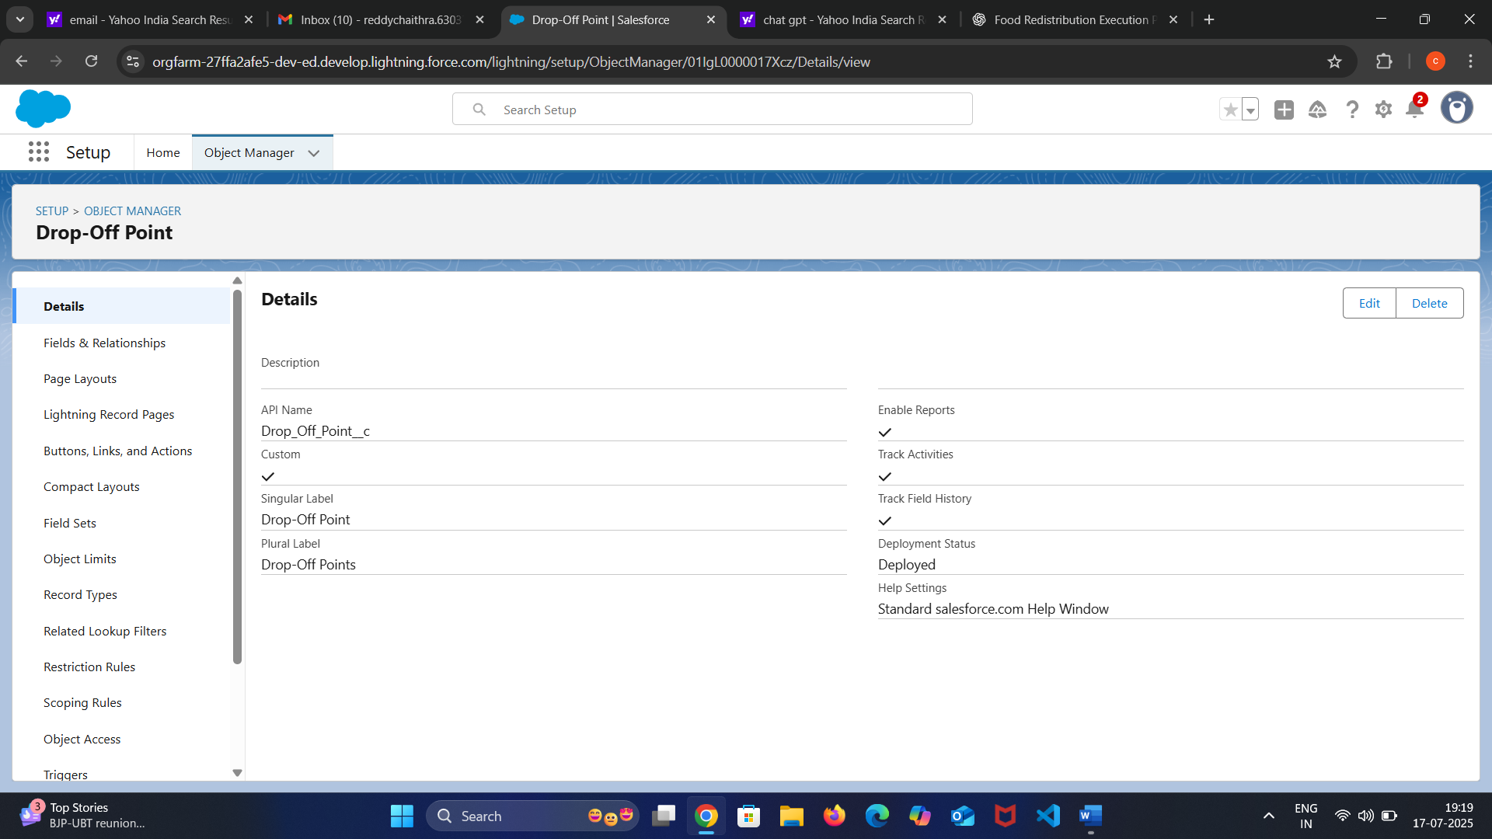

Tabs:-

In the project to supply leftover food to the poor, tab creation within the digital platform or mobile application is essential for streamlined operation and user interaction. The platform includes distinct tabs such as **“Food Donor”**, **“Pickup Request”**, **“Volunteer Dashboard”**, **“Drop-off Locations”**, **“Live Tracking”**, and **“Reports”**. The **Food Donor** tab allows restaurants or individuals to register and log available surplus food with details like quantity, pickup time, and location. The **Pickup Request** tab is used to assign and schedule food collection. The **Volunteer Dashboard** enables volunteers to view tasks, routes, and statuses. The **Drop-off Locations** tab lists all designated delivery points with maps and recipient capacity.

Creation of custom tabs:-

To create a new custom object tab, begin by navigating to the admin or developer settings of your application or platform (e.g., Salesforce Setup or your custom admin panel). Select the option to create a **“New Custom Object”**, and define its name—such as “Food Donation”, “Volunteer Task”, or “Drop-off Location”—along with a plural label, description, and appropriate permissions. Once the object is created, proceed to the **Tabs** section and choose **“Create New Tab”**.

Select the custom object you just created from the dropdown menu and assign an appropriate icon and tab style for easy identification. Configure visibility settings to determine which user roles (e.g., donor, volunteer, admin) can access the tab.

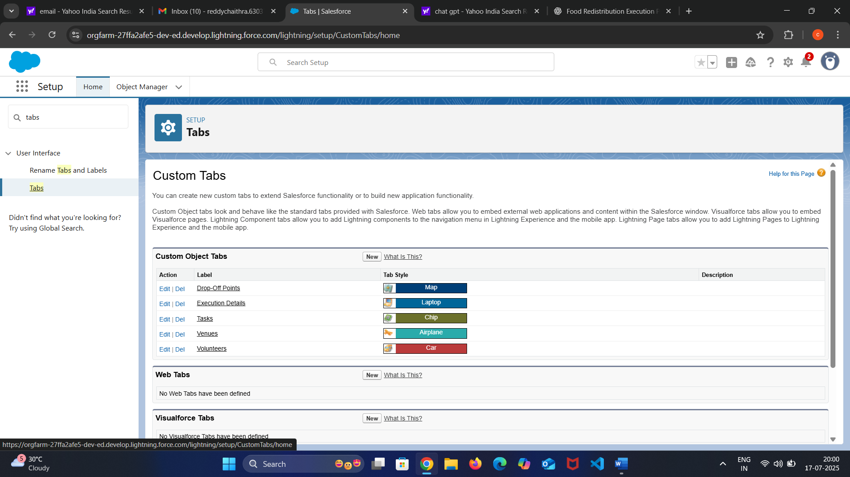

Lightning apps:-

In Salesforce Lightning Experience, the process of creating a Lightning App involves designing a tailored workspace that organizes relevant objects, tabs, and tools for specific users or functions. To begin, the administrator accesses the App Manager and selects the option to create a new Lightning App. During the setup, key details such as the app’s name, description, logo, and theme color are configured to give the app a distinct identity.

The app type is chosen based on the use case, typically set to Standard Navigation for most functional teams. User profiles are then assigned to control who can access the app. After that, relevant custom tabs—such as Food Donations, Volunteer Tasks, Drop-off Points, and Reports—are selected to be included in the app interface.

Optionally, a utility bar can be added for quick access to features like Notes, Recent Items, or a Chat panel. Once all settings are reviewed and confirmed, the app is saved and becomes accessible through the App Launcher. This structured process ensures each user role sees only the tools and data they need, improving efficiency, clarity, and user experience across the leftover food distribution project.

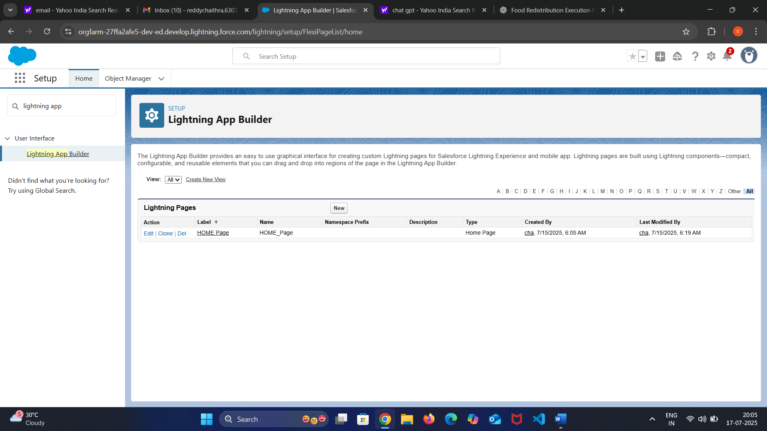

Fields and relationships:-

* In the leftover food redistribution project, creating custom fields and defining their relationships is crucial to building an efficient data model that connects donors, volunteers, food items, and drop-off points. The **Food Donation** object includes fields such as **Food Type** (Text), **Quantity** (Number), **Prepared Time** and **Expiry Time** (Date/Time), **Pickup Location** (Text/Geolocation), and **Status** (Picklist: Pending, Picked, Delivered, Expired).
* It also includes a **Donor Reference** (Lookup relationship to the Donor object) to associate the donation with its source. The **Volunteer Task** object has fields like **Assigned Volunteer** (Lookup to Volunteer), **Task Status** (Picklist), **Pickup Time**, and **Drop-off Time** (Date/Time), along with a **Related Food Donation** field (Lookup to Food Donation) to link tasks to specific donations.
* For the **Drop-off Point** object, fields include **Location Name**, **Capacity** (Number), **Area** (Text), and **Last Delivery Date** (Date). A **Relationship** between Drop-off Points and Volunteer Tasks is established using a Lookup field to track where food is delivered. Master-detail relationships can be used where a strong dependency exists, such as between **Food Donation** and its **Donation Images** (child records storing images of the food).

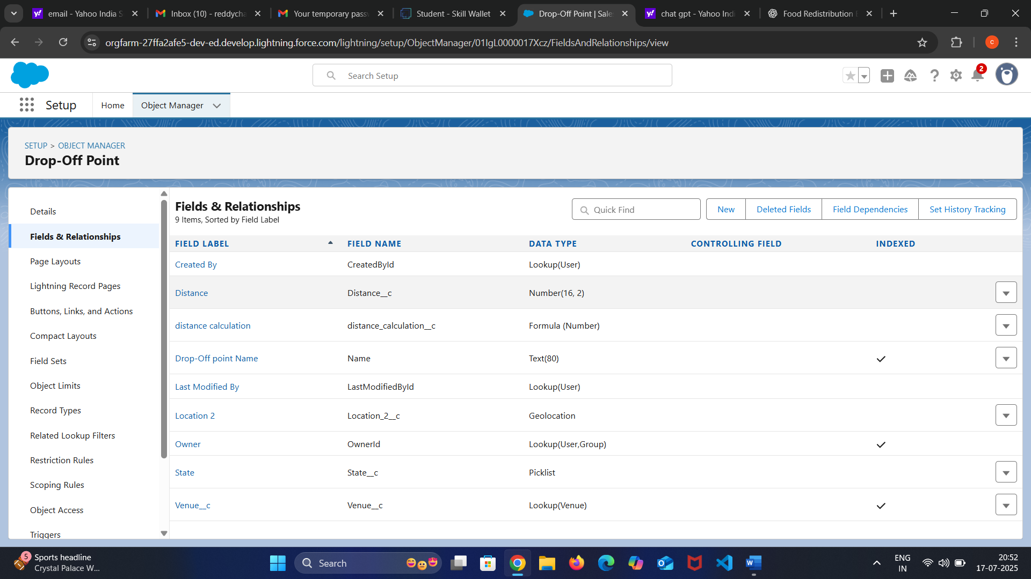

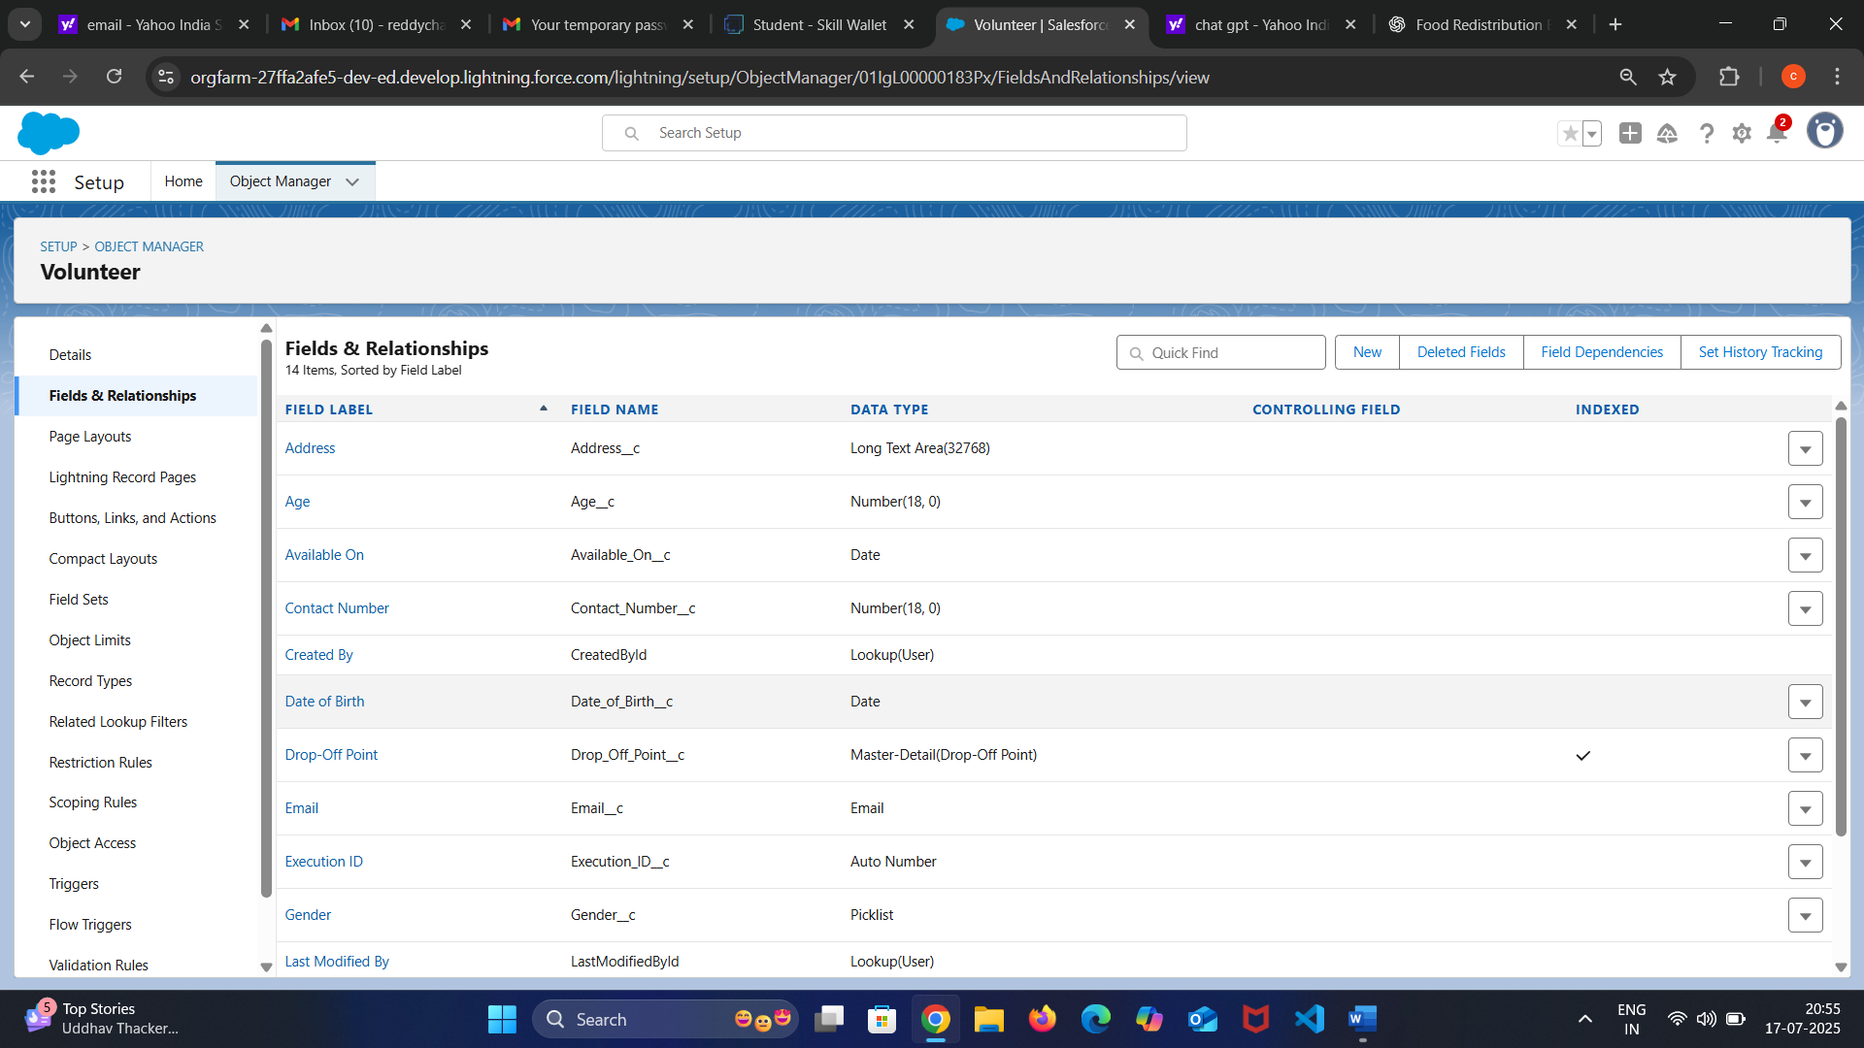

Flows:-

* To automate key processes in the leftover food distribution system, various flows are designed using a visual flow builder. One essential flow is the **“Food Donation Submission Flow”**, which is triggered when a donor submits a new food entry. This flow captures details such as food type, quantity, pickup location, and expiry time, then creates a corresponding record and assigns a pickup task to a nearby available volunteer.
* A **“Task Completion Flow”** updates the food status to "Delivered" when a volunteer marks the delivery complete, and logs the delivery details including time and drop-off point. Additionally, a **“Reminder Flow”** is set up to send alerts to volunteers for pending pickups nearing the expiry time, ensuring no food is wasted.
* These flows are created using a combination of record triggers, decision elements, assignments, and notification actions, forming an automated and reliable workflow that reduces manual coordination and enhances service delivery.
* In the leftover food redistribution system, a **Screen Flow** is used to provide an interactive and user-friendly interface for data entry and task handling.
* The flow displays screens to collect details such as food type, quantity, pickup location, expiry time, and contact information. It validates input, checks for completeness, and submits the data to create a new Food Donation record.

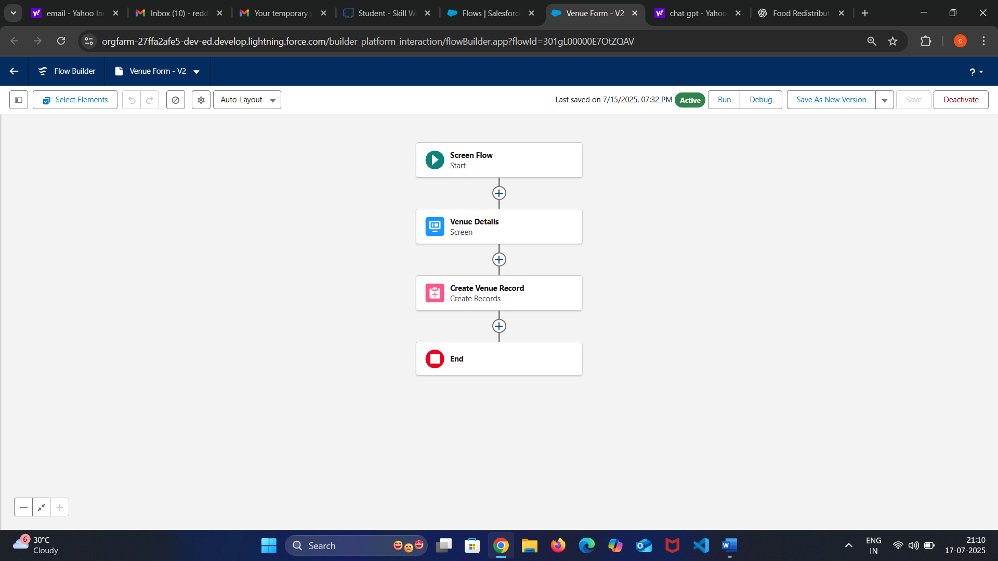

Trigger:-

* The trigger then creates a related volunteer task, assigns the food pickup, and sends a notification to the selected volunteer with all necessary details. Additionally, the trigger updates the food donation status to “Assigned” and links it to the volunteer task to maintain traceability.
* This ensures real-time response and minimizes delay between food availability and delivery, helping prevent food spoilage and ensuring the donation reaches the poor promptly. Such automated triggers improve operational efficiency, reduce manual effort, and streamline the entire process from donation to delivery.
* For instance, when a donor adds a new food entry, an **“after insert” trigger** activates to automatically check for nearby available volunteers based on the pickup location and urgency.

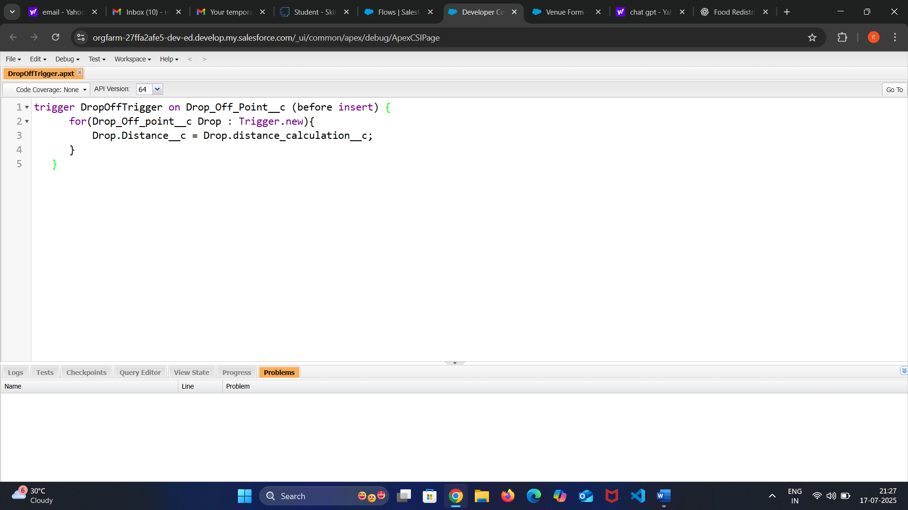

Trigger Logic:-

* When a new **Drop-Off Point** is being created, the system needs to store the distance from a fixed reference point (such as the food donor’s location or a distribution center).
* The field Distance_Calculation__c contains the calculated or pre-determined distance, either entered by the user or calculated earlier through a flow or integration.
* The trigger then **copies the value** from Distance_Calculation__c to Distance__c before the record is saved.
* This ensures that the Distance__c field always has the correct value, and it can be used later for filtering, reporting, or assigning the nearest volunteers for delivery.

Profiles:-

* The profile for the leftover food to connect for poor project is centered around a humanitarian initiative designed to bridge the gap between food excess and food scarcity. This project involves three key user profiles: **Food Donors**, **Volunteers**, and **Administrators**. Food Donors, including restaurants, event organizers, households, and canteens, use the system to register and submit details about available leftover food.
* This profile allows them to log food availability, manage drop-off details, and view food collection history. The **Volunteer Profile** is for individuals who manage food pickup and delivery logistics. They can access donor and receiver locations, update pickup status, and ensure timely delivery.
* The **Receiver Profile** is assigned to NGOs, shelters, or underprivileged communities registered to receive food. They can view available food, confirm receipt, and provide feedback. Each profile is carefully configured with necessary data visibility and access rights to ensure privacy, transparency, and smooth coordination across all roles in the food supply chain.

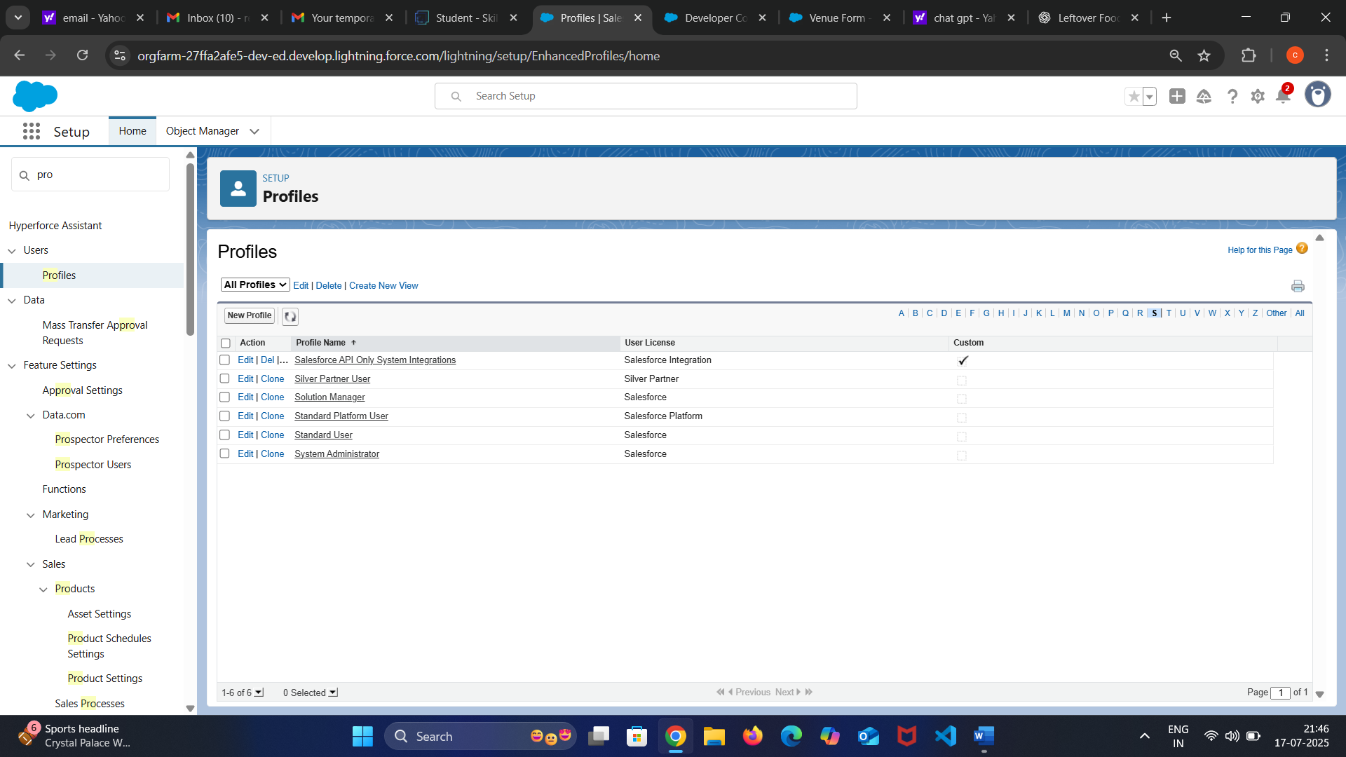

Creation of users:-

* When a new user signs up, they are required to provide basic information such as name, contact details, email, location, and role preference (Donor, Volunteer, or Receiver). Based on their selected role, the system assigns the appropriate **profile** that determines their access permissions and functionality within the application.
* A volunteer user is linked to delivery tasks and routing tools, while a receiver user can view available food and confirm collections. The system also verifies the identity of users through email or phone verification to maintain authenticity and security.

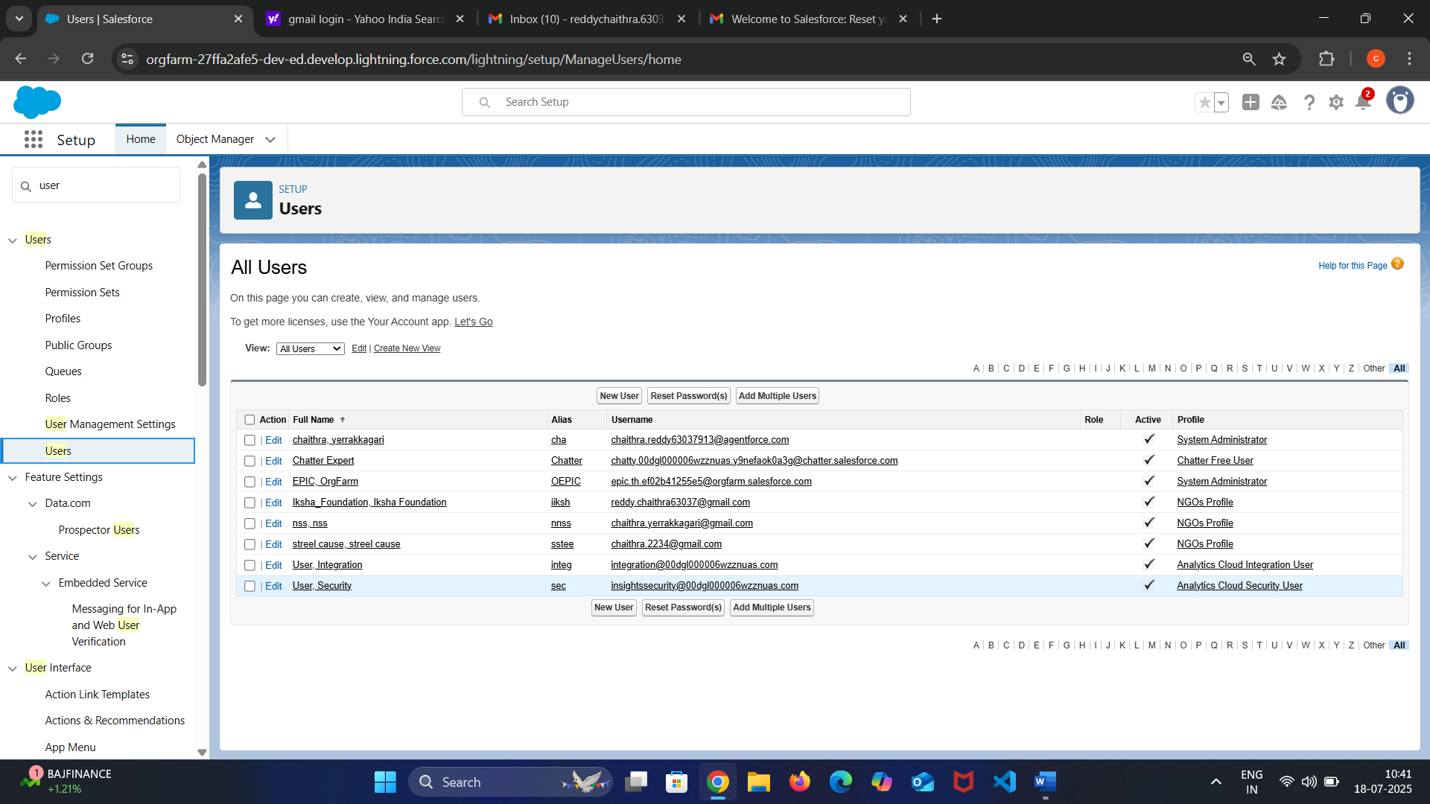

Creation of public groups:-

* In the leftover food to poor distribution process, Public Groups are created to efficiently manage and coordinate roles and responsibilities among various stakeholders such as donors, volunteers, transport coordinators, and administrators.
* These groups help in organizing users based on their functions and regions, ensuring proper access control and task assignment. For example, a Public Group named "Food Donors" can include users from restaurants and event organizers, while another group named "Volunteer Team" can include people involved in food collection and distribution
* By assigning appropriate sharing rules and permissions to these groups, we ensure that critical data like drop-off points, pickup schedules, and beneficiary information is accessible only to relevant members. This setup improves collaboration, enhances security, and streamlines the overall food to poor peoples process.

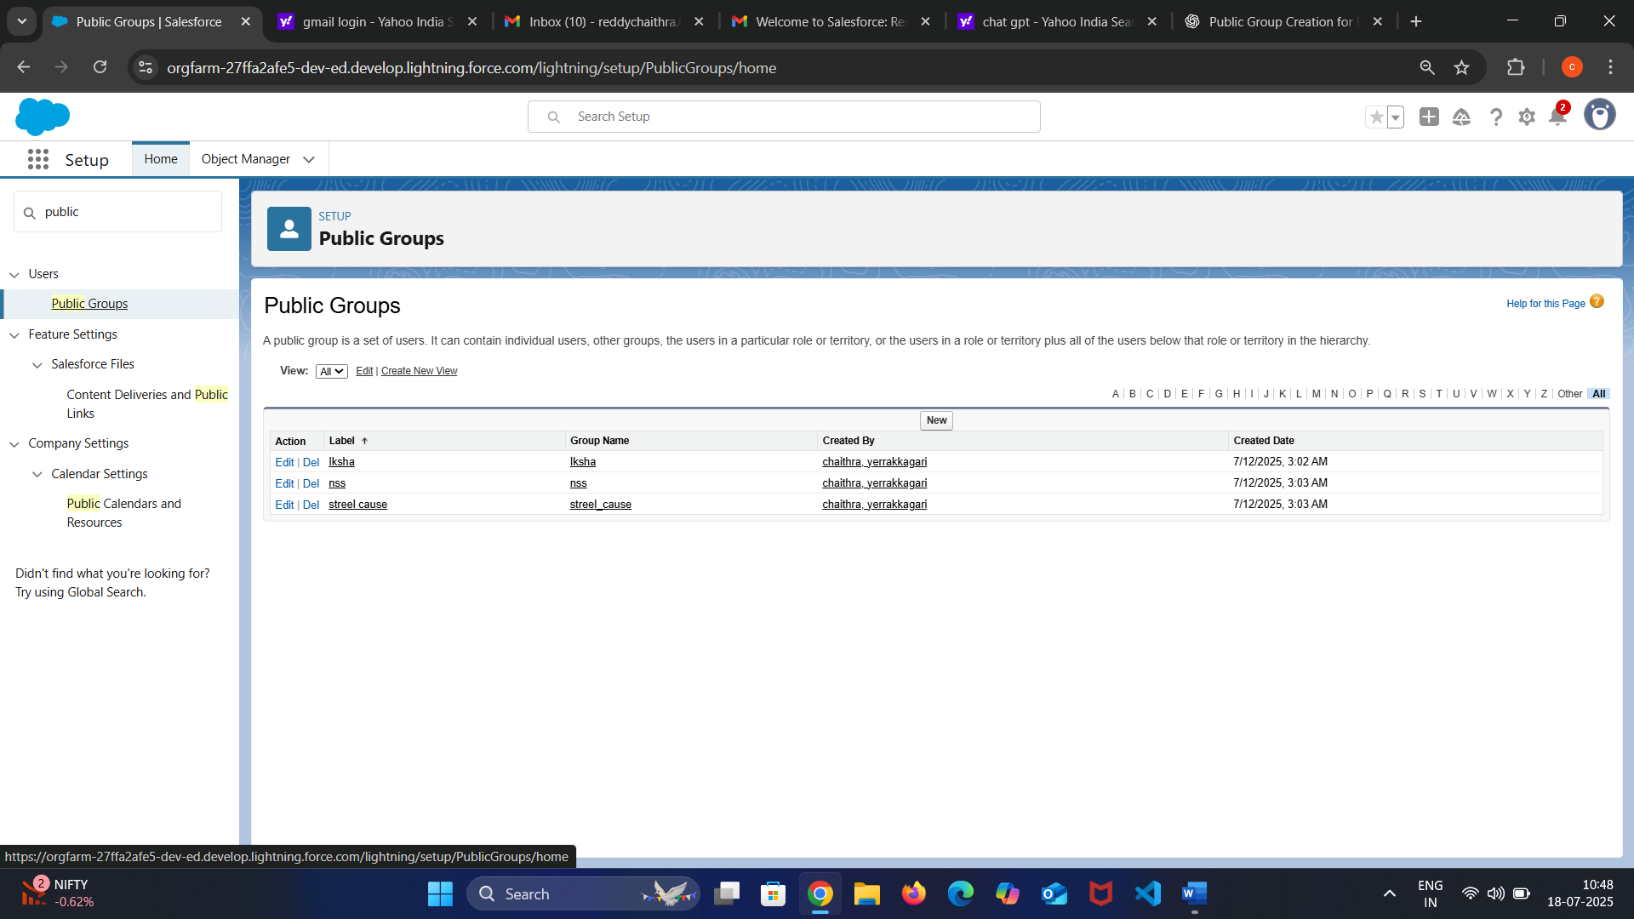

Records:-

* In the leftover food distribution project, record creation plays a vital role in tracking and managing all activities from donation to delivery. Various custom and standard objects like **Food Donation**, **Drop-Off Point**, **Volunteer**, **Beneficiary**, **Task**, and **Transport Schedule** are used to capture essential information. For instance, when a donor submits a request to donate food, a **Food Donation record** is created with details such as food type, quantity, expiry time, and pickup address.
* Simultaneously, a **Drop-Off Point record** is created or selected, indicating where the food will be delivered. Volunteers are then assigned through **Task records**, which are linked to the donation and distribution process.
* Each record is related and tracked using lookup or master-detail relationships, enabling seamless coordination. These records help in real-time status tracking, generate alerts for time-sensitive actions, and ensure transparency and accountability throughout the food distribution chain.

1. Creation of Report on Venue with drop off Volunteer:-
   * To ensure smooth coordination and monitoring of food redistribution activities, a report is created that links **Venue**, **Drop-Off Point**, and **Volunteer** records. This report helps administrators and coordinators track where food is being dropped off and which volunteers are assigned to each location.
   * The report is built using a **custom report type** that joins the **Venue object** (which holds location and contact details), the **Drop-Off Point object** (which contains food details, timings, and associated venue), and the **Volunteer object** (which includes volunteer names, contact numbers, and assigned duties).
   * Filters can be applied to display reports by date, location, or volunteer availability. This comprehensive report provides clear visibility into the operations, helps identify gaps in volunteer coverage, and supports data-driven decision-making for improving service efficiency and outreach.
2. Creation of report on Volunteers with Excution Detalis and Task:-

* To effectively manage and evaluate volunteer participation in the leftover food distribution project, a report is created that connects **Volunteers**, their assigned **Tasks**, and related **Execution Details**.
* This report provides a consolidated view of each volunteer’s contributions, including the nature of the task (e.g., food pickup, delivery, coordination), the scheduled and actual execution times, and the task status.
  + Built using a **custom report type** that includes the **Volunteer object**, **Task object**, and a related **Execution Detail object**, the report helps coordinators monitor performance, track delays or issues, and plan future assignments.
  + Filters such as task status, execution date, or volunteer name can be applied to generate specific insights. This report not only supports better accountability and recognition of volunteer efforts but also ensures smoother logistical planning and improved service delivery.

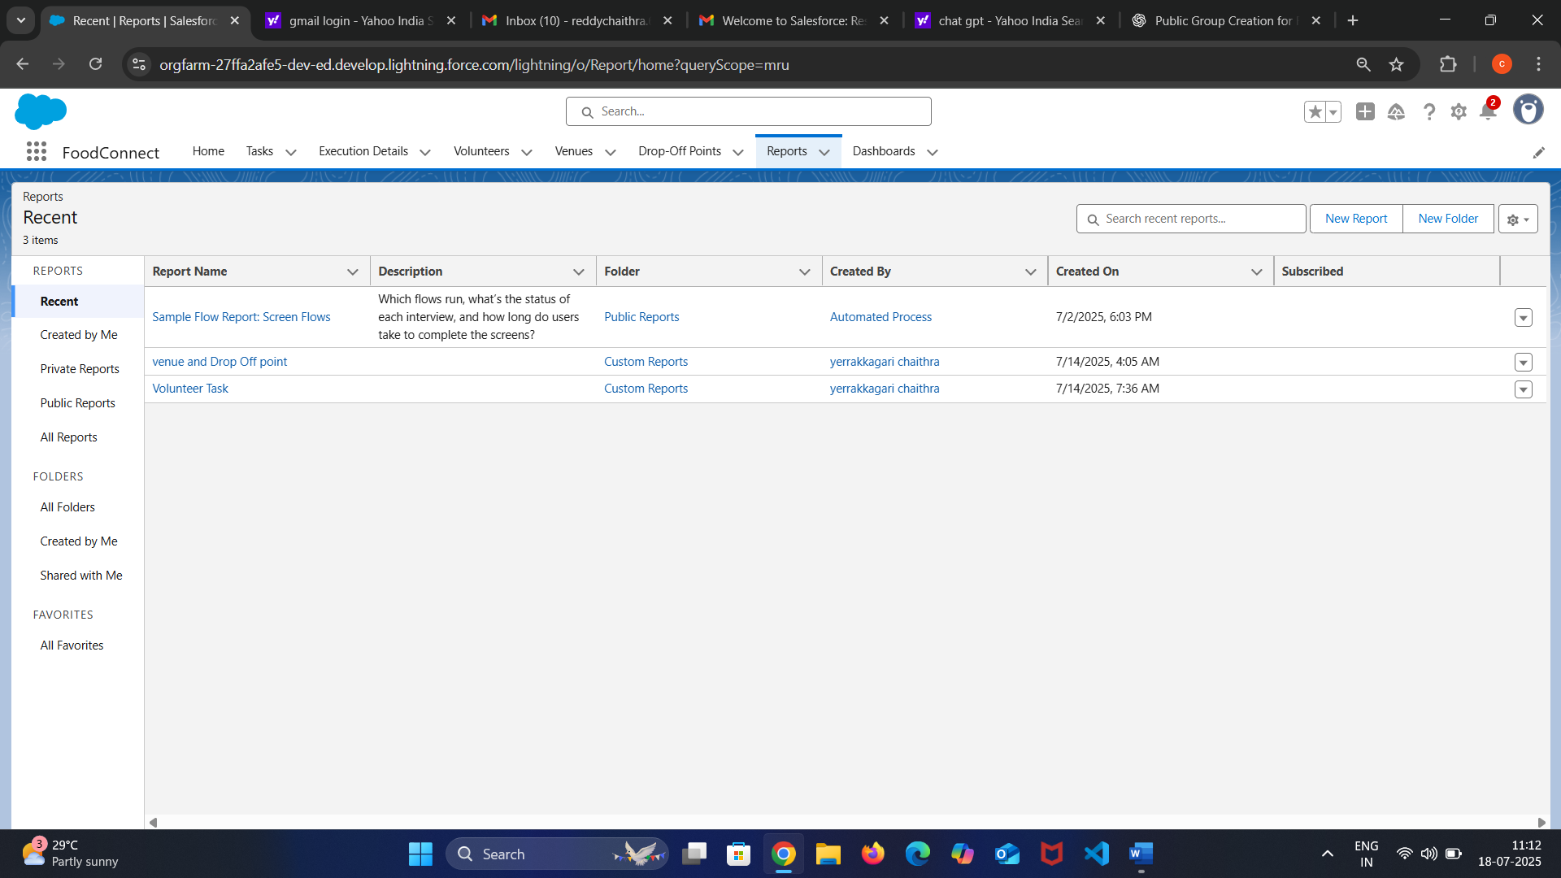

Dashboard:-

* Dashboards are created to visually monitor and analyze the overall performance of the leftover food distribution system in real time. These dashboards compile data from various reports related to **donations, volunteers, drop-off points, venues, and task execution**, presenting them through interactive charts, graphs, and metrics.
* Key components include **Total Food Donations**, **Active Drop-Off Points**, **Volunteer Participation Rate**, **Completed vs. Pending Tasks**, and **Top Venues by Donation Volume**. Filters such as date range, location, or volunteer group can be applied to customize the view.
* These dashboards compile data from various reports related to **donations, volunteers, drop-off points, venues, and task execution**, presenting them through interactive charts, graphs, and metrics. Key components include **Total Food Donations**, **Active Drop-Off Points**, **Volunteer Participation Rate**, **Completed vs. Pending Tasks**, and **Top Venues by Donation Volume**.
* Filters such as date range, location, or volunteer group can be applied to customize the view. These dashboards provide project managers and stakeholders with valuable insights into operational efficiency, volunteer utilization, and area-wise distribution trends.
* This helps in identifying bottlenecks, forecasting needs, and making informed decisions for future resource allocation and service expansion. The dashboards are regularly updated and serve as a centralized tool for transparency, accountability, and strategic planning.

1. Adding Vlounteer Task Report to the dashboard:-
   * This report highlights the number of tasks assigned, completed, or pending for each volunteer, along with execution details such as date, time, and status.
   * When integrated into the dashboard, it appears as visual components like bar charts, pie charts, or summary metrics, making it easy to track task distribution and volunteer performance at a glance.
   * Including the Volunteer Task Report in the dashboard improves operational oversight and promotes data-driven decision-making across the food distribution network.
2. Adding Venue and Drop off point report to the dashboard:-
   * This report displays detailed information about each venue, the associated drop-off points, the volume of food handled, and the status of deliveries.
   * When added to the dashboard, it can be represented using maps, heat charts, or tabular components, offering a visual overview of active venues and their logistics flow.
   * Including this report in the dashboard allows coordinators to monitor distribution activity geographically, identify high-demand zones, and ensure optimal coverage and resource deployment. It enhances decision-making, improves logistical planning, and ensures no region is underserved.
3. Adding a picture to the Dashboard:-
   * This image can serve as a visual header, organizational logo, or a motivational banner to reflect the mission of the project. In platforms like Salesforce, this is done by first uploading the image to the **Documents** or **Files** section and then embedding it into the dashboard using a **Dashboard Component of type “Visualforce Page” or “Image”**.
   * Adding such visuals helps communicate the purpose of the dashboard more effectively to stakeholders and users, while also making the interface more engaging. It creates a meaningful connection between the data and the impact of the project, inspiring users and emphasizing the humanitarian goal behind the operations.

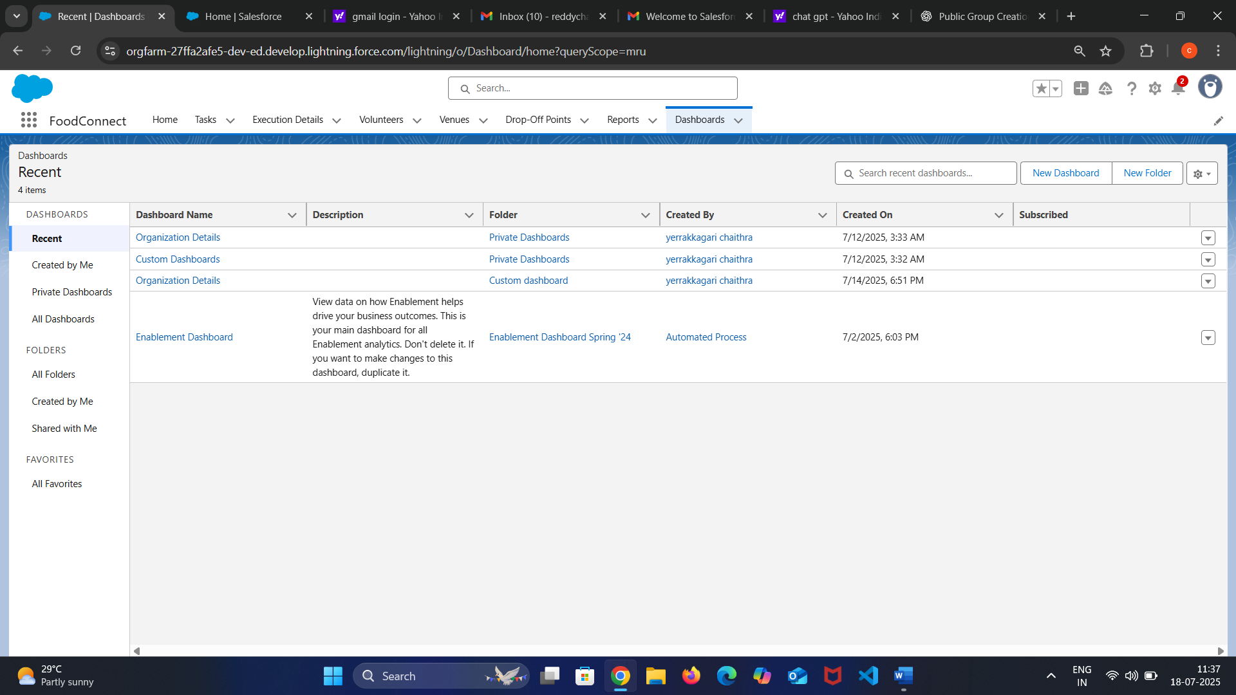

Sharing rules:-

* In the leftover food distribution project, **sharing rules** are implemented to ensure secure and controlled access to records based on roles and responsibilities. While **Organization-Wide Defaults (OWDs)** define the baseline access level (such as private or read-only), sharing rules are used to **extend access** to specific users, roles, or public groups.
* For instance, if the **Food Donation** object has its access set to private, a sharing rule can be created to allow members of the **Volunteer Group** or **Coordinator Role** to read or edit donation records assigned to their area. Similarly, **Drop-Off Point** records can be shared with **Logistics Managers** based on venue location.
* Sharing rules can be defined using **criteria-based** logic (e.g., share if the donation is in a certain city) or **owner-based** logic (e.g., share records owned by users in a specific role). This process ensures that users have the appropriate access to perform their duties while maintaining data security and integrity across the system.

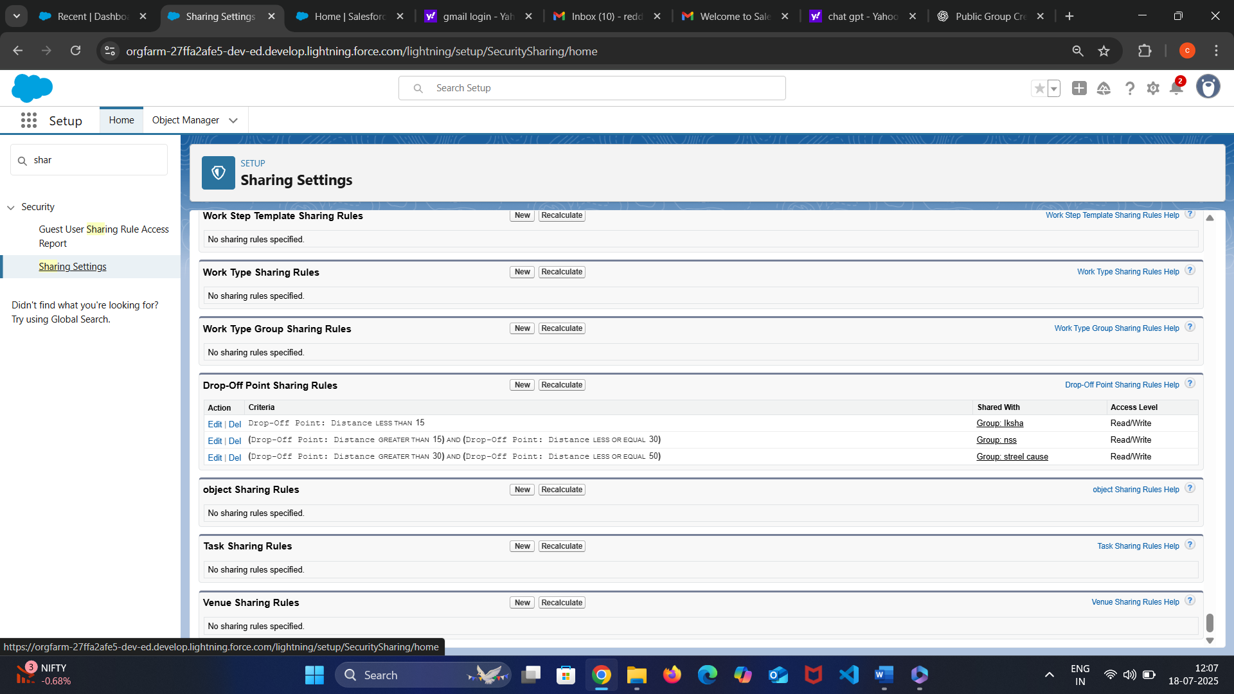

Home Page:-

* In the leftover food distribution project, the **Home Page** is designed as a central hub that provides users with quick access to key functionalities, real-time updates, and essential project information.
* The home page includes important components such as a **dashboard summary**, **recent donation records**, **upcoming tasks**, **volunteer schedules**, and **alerts or notifications** for urgent pickups or deliveries.
* A **quick action panel** is also added to allow users to easily log a new food donation, assign a volunteer, or create a drop-off request. The layout is role-based, ensuring that donors, coordinators, and volunteers each see relevant data and tools upon login. Motivational banners, project mission statements, or a dynamic image showing recent activities can be embedded to give the homepage a meaningful and engaging look.

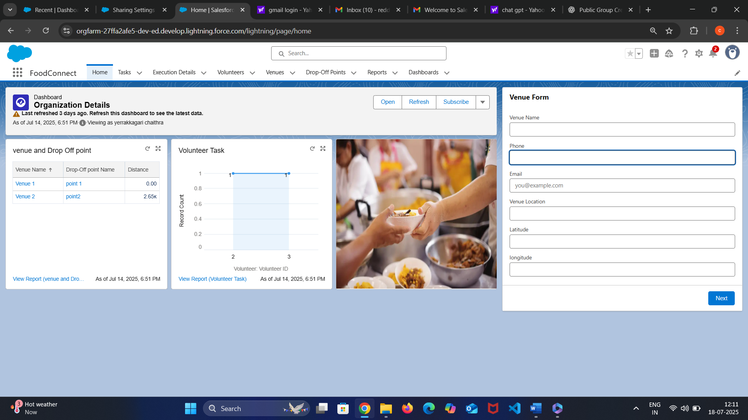

key scenario addressed by salesforce in the implementation project:-

**step 1:Donor Submits a Food Donation**

* A restaurant or event partner logs into the system and submits a **Food Donation form**.
* A **Food Donation record** is automatically created in Salesforce with details like food type, quantity, expiration, and pickup address.

**Step 2: System Identifies Nearby Drop-Off Points**

* Using custom logic or Flows, Salesforce **calculates nearby drop-off points** based on donor location and available storage capacity.
* A **Drop-Off Point record** is created or linked accordingly.

**Step 3: Volunteer Assignment**

* Salesforce checks **volunteer availability** in the area using Volunteer records and their schedules.
* A **Task record** is created and assigned to the most suitable volunteer for pickup and delivery.
* Volunteers are notified via **email or mobile alerts** through Salesforce automation (e.g., Process Builder or Flow).

**Step 4: Task Execution and Status Update**

* The volunteer picks up the food and updates the task status (e.g., In Progress → Completed).
* If integrated with a mobile app or community portal, volunteers can log real-time updates and photos.

**Step 5: Delivery Confirmation**

* The delivery is confirmed at the Drop-Off Point or with the end beneficiary.
* An **Execution Detail record** is created capturing date, time, and any notes or issues.

**Step 6: Reporting and Monitoring**

* Salesforce automatically updates **dashboards and reports** showing:
  + Number of donations
  + Volunteer performance
  + Drop-off success rate
  + Geographic distribution coverage

**Step 7: Visibility and Data Security**

* Using **Roles, Profiles, and Sharing Rules**, data is securely accessed:
  + Donors can see only their submissions
  + Volunteers see only their tasks
  + Admins and coordinators have full oversight.

Benefits of the Project:-

* The leftover food distribution project brings significant **social, operational, and technological benefits**. Most importantly, it helps **reduce food wastage** by redirecting surplus food to those in need, addressing both **hunger and sustainability**.
* By using Salesforce as the core platform, the project benefits from **centralized data management**, ensuring smooth coordination between donors, volunteers, and delivery points. Automation of tasks like food donation logging, volunteer assignment, and delivery tracking leads to **improved efficiency and reduced manual errors**.
* Real-time dashboards and reports offer **full visibility into operations**, enabling faster decision-making and better resource allocation. Secure access control through roles and sharing rules ensures **data privacy** while allowing stakeholders to collaborate effectively.
* Additionally, the platform supports **scalability**, making it easier to expand the initiative to new areas and communities. Overall, the project fosters **social impact, operational transparency**, and **technological empowerment** in fighting food insecurity.

**Reduction in Food Waste:-**

* Surplus food from restaurants, events, and households is collected instead of being discarded.
* This helps reduce **environmental impact** and supports **sustainability goals**.

**Timely Support to the Needy:-**

* The project ensures that **edible food reaches the poor and hungry** quickly, reducing food insecurity.
* It promotes **social welfare** by supporting underprivileged communities.

**Automation of Operations:-**

* Using Salesforce, manual tasks like **recording donations, assigning volunteers, and tracking deliveries** are automated.
* This reduces **human error**, saves time, and improves overall **efficiency**.

**Real-Time Monitoring and Reporting:-**

* Dashboards and reports provide **real-time insights** into donation volumes, task status, and volunteer performance.
* Enables project managers to make **data-driven decisions**.

**Streamlined Communication:-**

* Automated **notifications and alerts** keep donors, volunteers, and coordinators informed about tasks and updates.
* Improves **coordination and accountability**.

**Secure and Role-Based Access**

* With Salesforce's **role hierarchy and sharing rules**, users only access the data relevant to their role.
* Ensures **data privacy, transparency, and trust** among stakeholders.

**Scalability and Expansion:-**

* The system is built to **easily scale** across cities or regions.
* Enables the project to grow its impact and reach **more beneficiaries** without redesigning the process.

Deployment strategy:-

**1.Planning Phase**

* **Identify components** to be deployed: Custom objects (Food Donation, Drop-Off Point, Volunteer, Task), Flows, Validation Rules, Reports, Dashboards, Page Layouts, Profiles, and Sharing Rules.
* Define **roles and responsibilities**: Developers, admins, testers, deployment leads.
* Establish environments:
  + **Sandbox (Developer/Full)** for development and testing.
  + **Production** for live deployment.

**2. Development Phase**

* Configure and customize objects, fields, relationships.
* Build automation using **Flows**, **Process Builder**, or **Apex** (if needed).
* Design **Reports & Dashboards** for operations monitoring.
* Set up **profiles, roles, and sharing rules** for secure data access.

**3. Testing Phase**

* Conduct **Unit Testing** for each component (e.g., test if volunteer task assignment Flow works).
* Perform **System Integration Testing (SIT)** to ensure all modules work together.
* Carry out **User Acceptance Testing (UAT)** with actual project coordinators and volunteers.

**4. Deployment Phase**

* Use **Change Sets** (or Salesforce CLI, ANT Migration Tool for advanced control) to migrate components from Sandbox to Production.
* Perform a **pre-deployment checklist**:
  + Ensure all dependent components are included.
  + Validate profiles and permissions.
* Conduct a **pre-deployment backup** of existing production metadata and data.

**5. Post-Deployment Phase**

* Run **post-deployment validations**:
  + Confirm automation works.
  + Verify user access and data visibility.
* Notify users of go-live and provide **quick reference guides**.
* Enable **logging and monitoring** to track usage and errors.

**6. Rollback Plan**

* Keep backup of metadata before deployment.
* In case of critical issues, **roll back manually** using backup or redeploy previous version from Git/version control.

**7. Training & Support**

* Provide **training sessions** for end users (donors, volunteers, coordinators).
* Set up a **support plan** for issue reporting, resolution, and system enhancements.

System maintance and montoring:-

The leftover food distribution system will be **regularly maintained and monitored** to ensure smooth operation, data accuracy, and user satisfaction. Maintenance involves **updating records**, fixing bugs, managing user access, and enhancing features based on feedback. **Scheduled reviews** will be performed to clean outdated or duplicate data, update task workflows, and verify security settings such as profiles, roles, and sharing rules.

For monitoring, **dashboards and reports** will track system performance, such as the number of donations, completed tasks, volunteer activity, and delivery success rates. **Error logs and system alerts** will be reviewed frequently to detect and resolve issues early.

Conclusion :-

The leftover food distribution project, powered by Salesforce, presents an innovative and impactful solution to address food wastage and hunger in a structured, efficient, and scalable manner. By integrating key functionalities such as real-time donation tracking, volunteer coordination, drop-off point management, and automated task assignment, the system ensures timely and organized food delivery to those in need. Through the use of dashboards, reports, and secure data sharing, stakeholders gain full visibility and control over operations, allowing for continuous monitoring and improvement. The platform also supports scalability, enabling the project to expand across regions with minimal changes. Ultimately, this project not only promotes sustainability and social responsibility but also demonstrates how technology can be leveraged to create meaningful change in communities.